Shared Safety Net Action Plan (SSNAP) Feasibility Study
SystmOne SSNAP End User Guide



This user guide is designed to support SystmOne users with using the SystmOne Shared Safety Net Action Plan (SSNAP) functionality. For general SystmOne functionality queries please consult the system’s Help Files or contact your organisation’s training department. SSNAP functionality does not replace your organisation’s normal safety netting and business processes.

Contents

Step 1 – Locating existing Test Patient(s) 2
Step 2 – Marking a patient as a test patient 3
Step 3 – Using the SSNAP Dashboard & Action Plan Template 4
Step 4 – How to create a Reminder 7
Step 5 – Creating a Letter (generating the Monitoring Chart) 9
Step 6 – Printing a Letter (printing the Monitoring Chart) 11
Step 7 – Communications Annexe (sending the letter & monitoring chart digitally) 13
Step 8 – Scheduled Tasks 20
Step 9 – Viewing SSNAP content in the Patient Record 23
Step 10 – How to Action an Online Questionnaires (Digital SSNAP Monitoring Chart) 26

Step 1 – Locating existing Test Patient(s)

To identify existing Test Patients registered at your organisation, Navigate to Reporting (off the main menu) – Miscellaneous Reports – Test Patients.

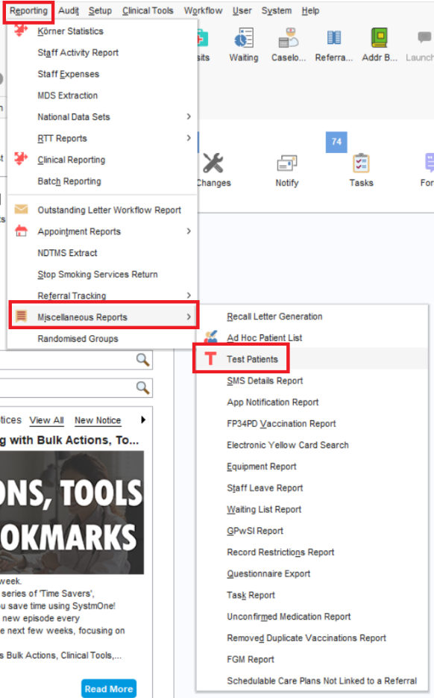

The list of test patients registered at your organisation will be displayed. Double-click on a patient to retrieve their record or select the patient and click Retrieve Patient.
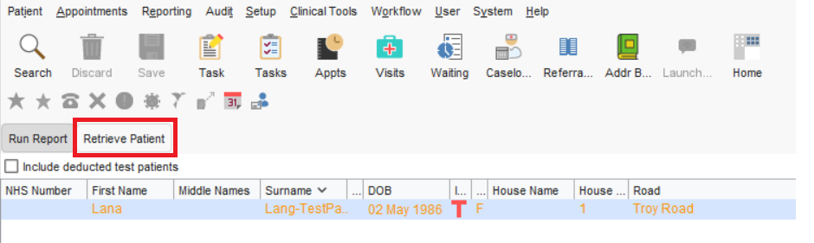

Step 2 – Marking a patient as a test patient

If you would like to create a new test patient, register a patient as per your organisation’s normal registration procedure. With the record retrieved, navigate to Patient (from the main menu) – Patient Maintenance – Patient Details.

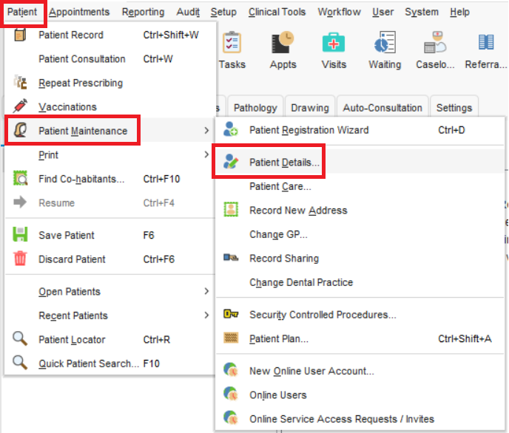
The Patient Details screen will be displayed. Click the Test Patient Record tick box and click Ok to confirm. Save the record as per normal process.

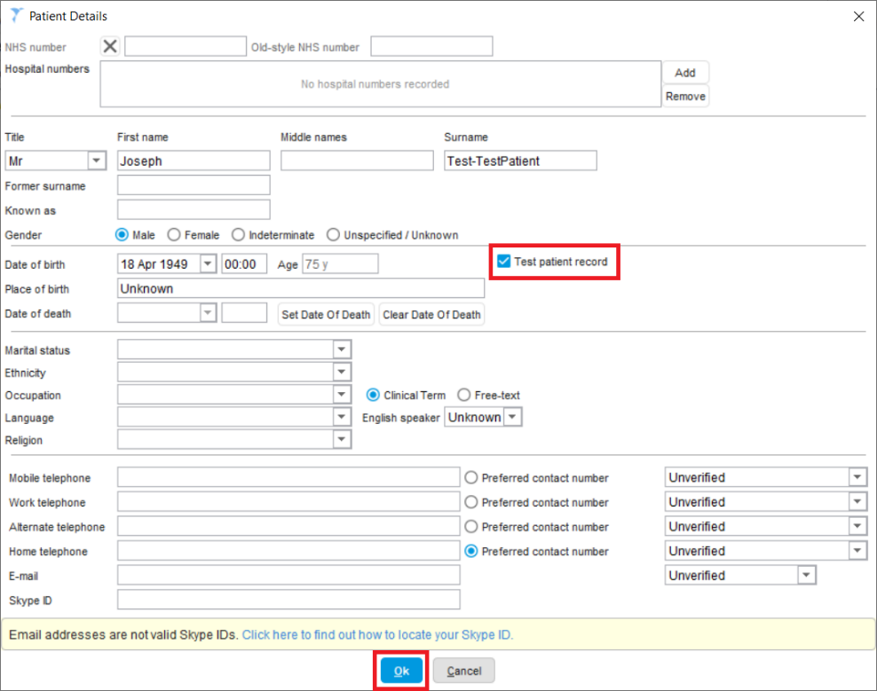

Step 3 – Using the SSNAP Dashboard & Action Plan Template

To use the SSNAP dashboard, retrieve the patient record and locate the SSNAP Dashboard on the tree. Either double-click or right-click and select SSNAP Dashboard.

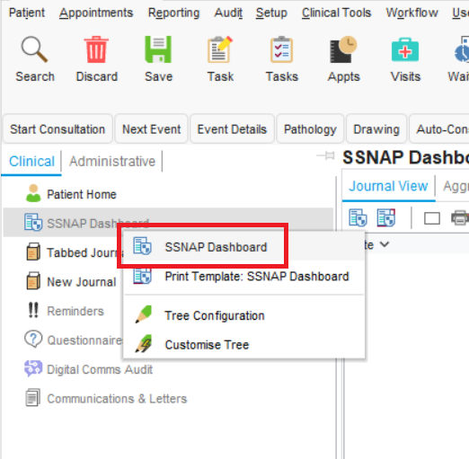

The SSNAP Dashboard template will be displayed. Click on the Shared Safety Net Action Plan – SSNAP template.

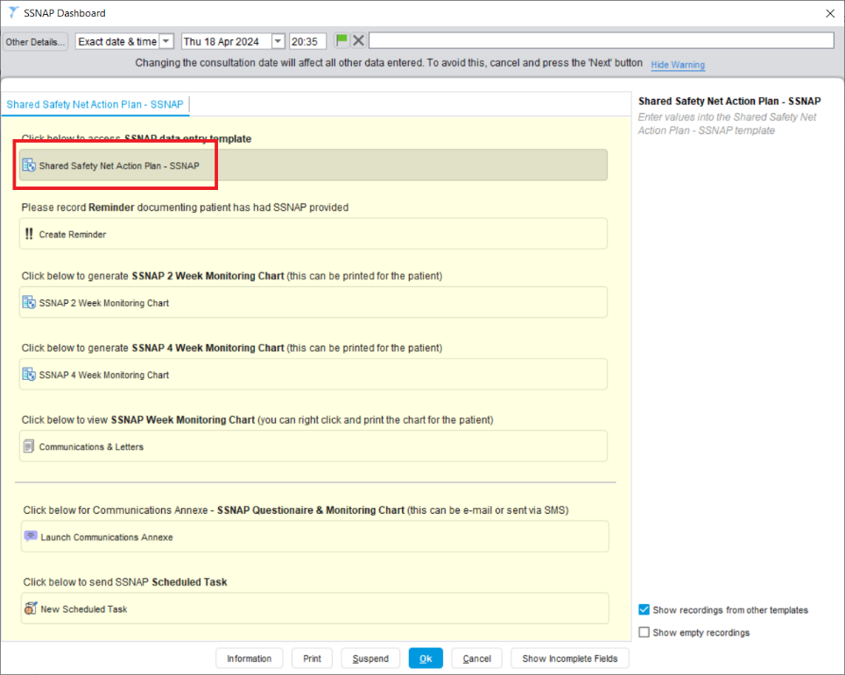
The Shared Safety Net Action Plan – SSNAP template will be displayed. The template is primarily made up of tick-boxes and note boxes.

Anything you enter in the SSNAP template not only becomes part of the patient’s electronic record, but it also generates a code in SystmOne which the research team will use to identify SSNAP patients.

Click on a tick-box as required. The tick-box will turn blue when selected. To add notes against the tick-box, click on the pencil icon and a notes box will be displayed. Enter any relevant notes against that specific tick-box. Click Ok to confirm.

Click Ok to confirm the changes.
To enter notes into the note boxes, simply type into each box as required.

Please note: the text from these notes boxes will be merged into the SSNAP letter which can be printed for patients to monitor, or texted or emailed to them.

Tip: You can right click in any notes field and select Automatically Check Spelling to enable the automatic spell check.

Click Ok to confirm the changes. Please note, selecting cancel will cancel all information entered in the template.

Step 4 – How to create a Reminder

A patient Reminder will appear on the Patient Home screen whenever a patient record is retrieved. A Reminder will also appear whenever an Appointment or Visit is booked for the patient.

To create a Reminder, select the Create Reminder button on the SSNAP Dashboard.

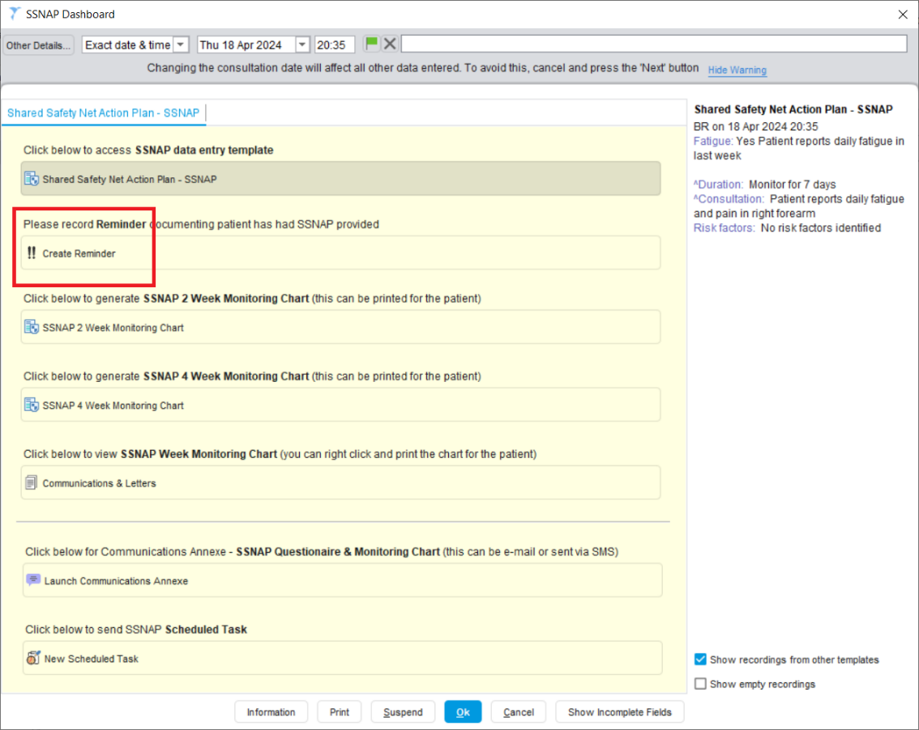

The Create New Reminder box will be displayed. Choose which the priority level of the Reminder.

- Low Priority reminders are only shown to the person who has recorded them.
- Normal priority reminders are shown to everyone at your organisation.
- High priority reminders are shown to everyone across multiple organisations using SystmOne (dependent upon record sharing permissions). If you work in PCN or group where patients may see practitioners in other practices after your safety-netting consultation with them, it’s recommended you type ‘Patient safety-netted with SSNAP’ in a high priority reminder so that staff in the other practices in your group know about SSNAP.

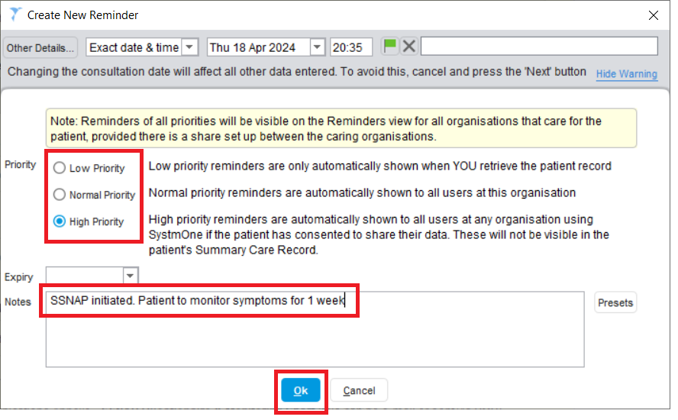
Patient safety-netted with SSNAP
Enter relevant notes into the Notes box. Click Ok to confirm the changes.

Step 5 – Creating a Letter (generating the Monitoring Chart)

If the patient requires a paper-based SSNAP letter/monitoring chart this can be printed from the SSNAP Dashboard. Click on the relevant Monitoring Chart (2 week or 4 week) quick action button.

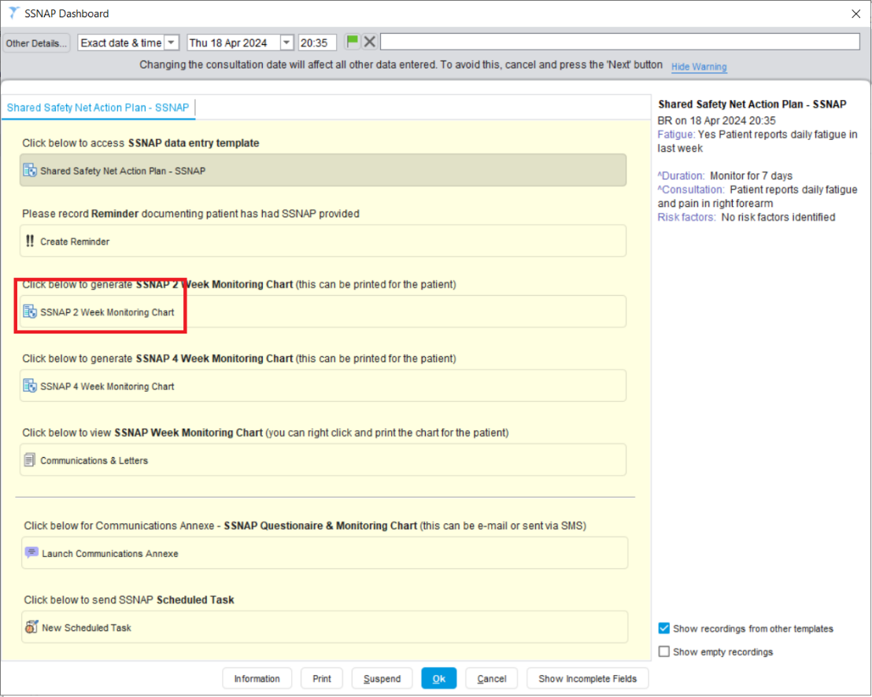

The New Letter box will be displayed. The Recipient and Sender fields of the New Letter will be pre-populated. The letter and letter type should also be pre-populated. Click Write Now to generate the letter.

Microsoft

Word should automatically launch and the SSNAP letter will be displayed. The content entered in the Shared Safety Net Action Plan – SSNAP template will be merged into the corresponding boxes within the letter (see below). Please check the content of the letter before selecting Save Final Version which will lock the letter for future editing.

Step 6 – Printing a Letter (printing the Monitoring Chart)

To print a paper copy of the letter click on Communications & Letters from the Shared Safety Net Action Plan – SSNAP template.

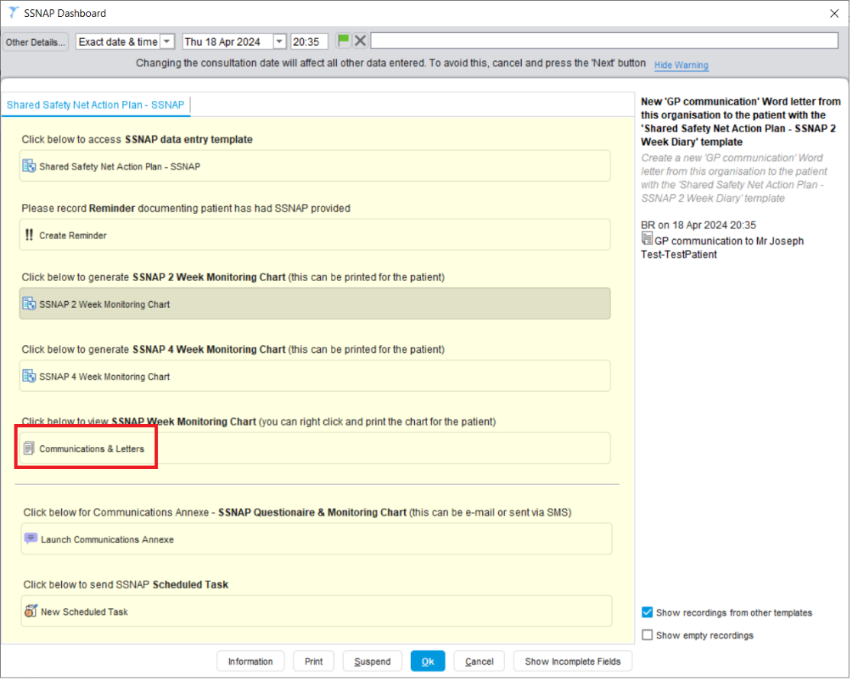

The Communications and Letters pop out node will be displayed. Right-click on the SSNAP letter and select Print. The letter will be sent to your default printer for printing.
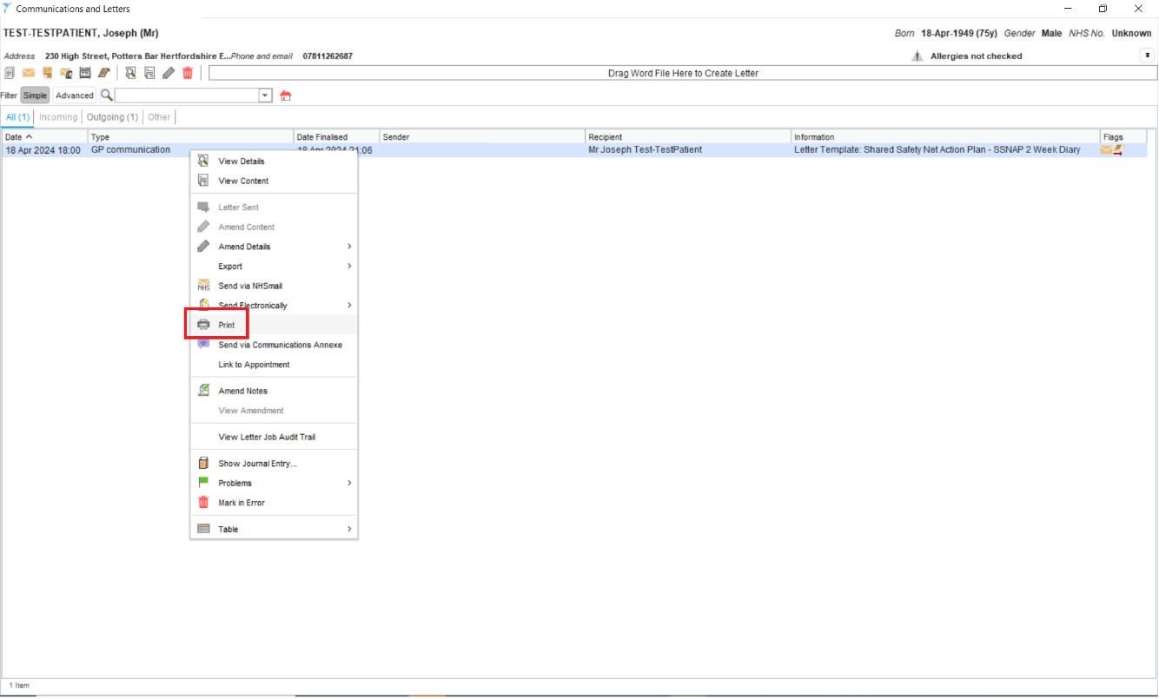

To close the Communications and Letters pop out node, click on the cross in the top right of the window.

Step 7 – Communications Annexe (sending the letter & monitoring chart digitally)

If the patient requires a digital SSNAP letter and monitoring chart this can be generated from the SSNAP Dashboard. Click on the relevant Launch Communications Annexe quick action button.

Please note: your organisation will need to be enabled for e-mail and SMS messaging to be able to use the Communications Annexe functionality. Please consult the systems Support and FAQ’s section or contact your SystmOne administrator for guidance.

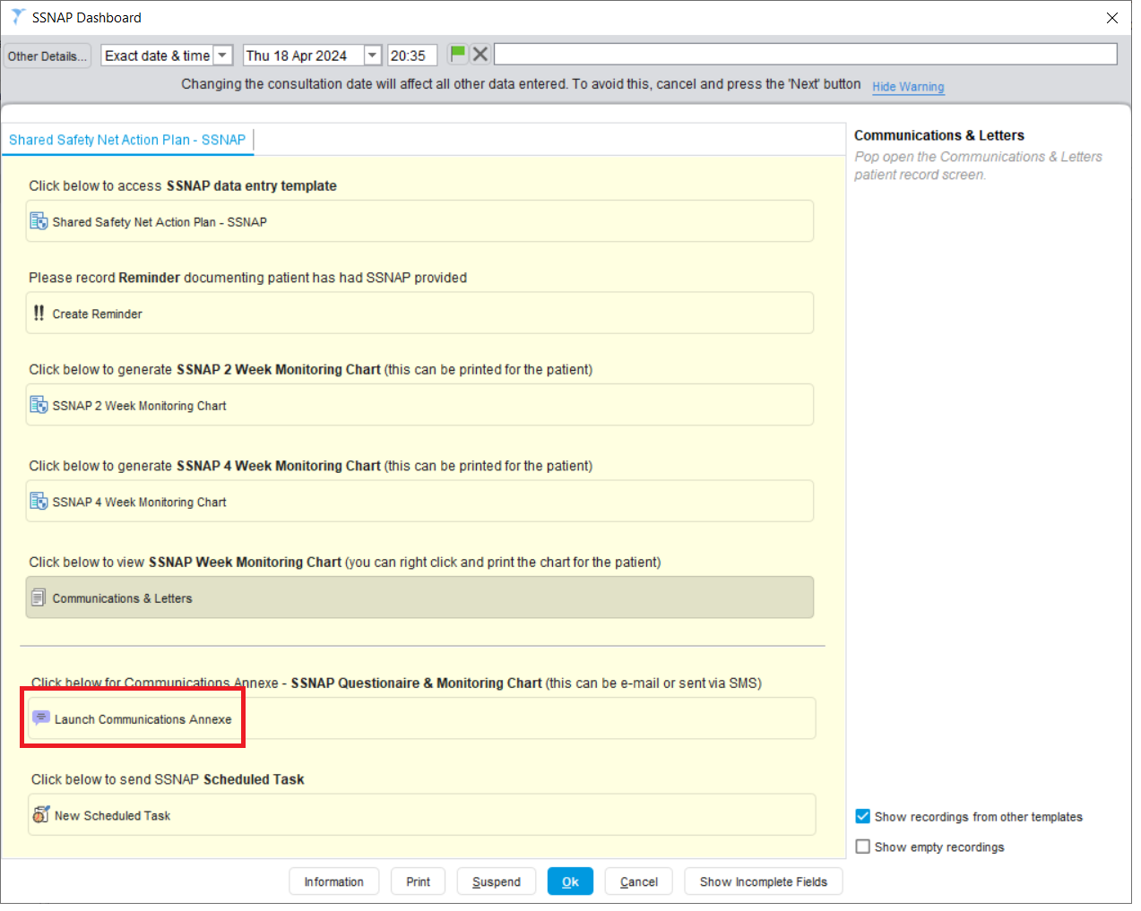

The Communications Annexe window will be displayed. The patient’s demographic details such as phone number and e-mail address etc, will be displayed.

If these need to be updated please select the green telephone icon.

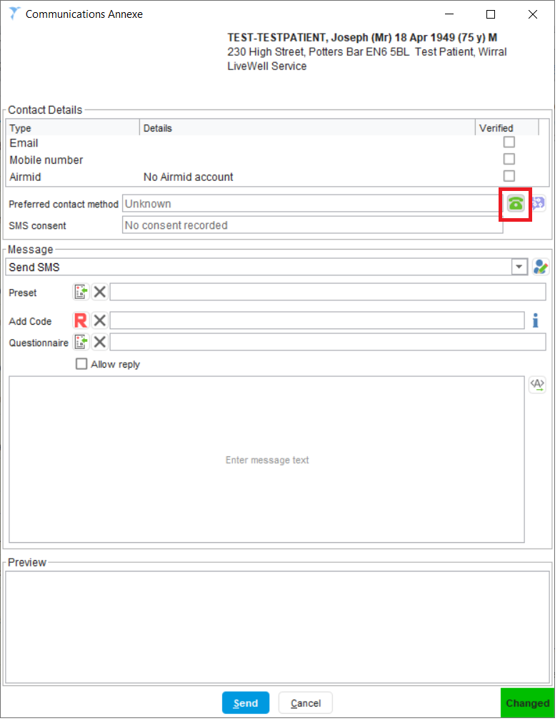

The Telephone Numbers & Email box will be displayed. Ensure SMS consent is recorded (your organisation may automatically apply SMS Consent by default) and check the patient’s mobile number is correct. Make any necessary changes and click Ok to confirm.
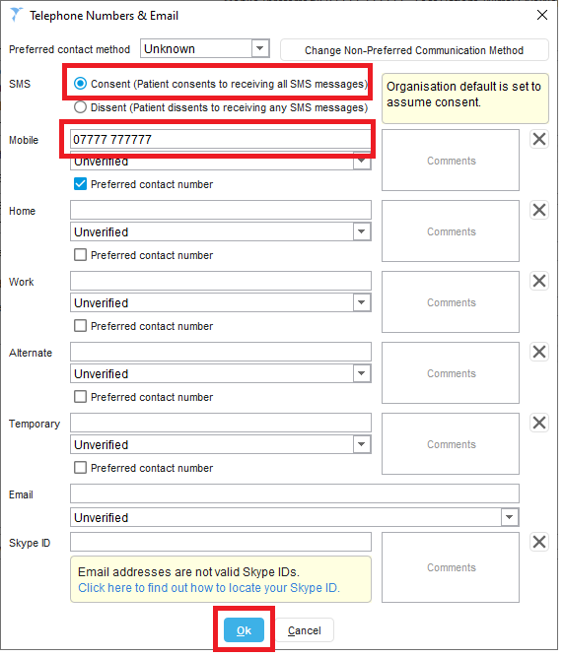

You can also send Communication Annexe messages to alternative mobile numbers. This is useful for sending messages to proxy contacts such as guardians, carers or relatives etc.

To send to a proxy contact click on the Send to alternative contact address button (otherwise do not select this option).
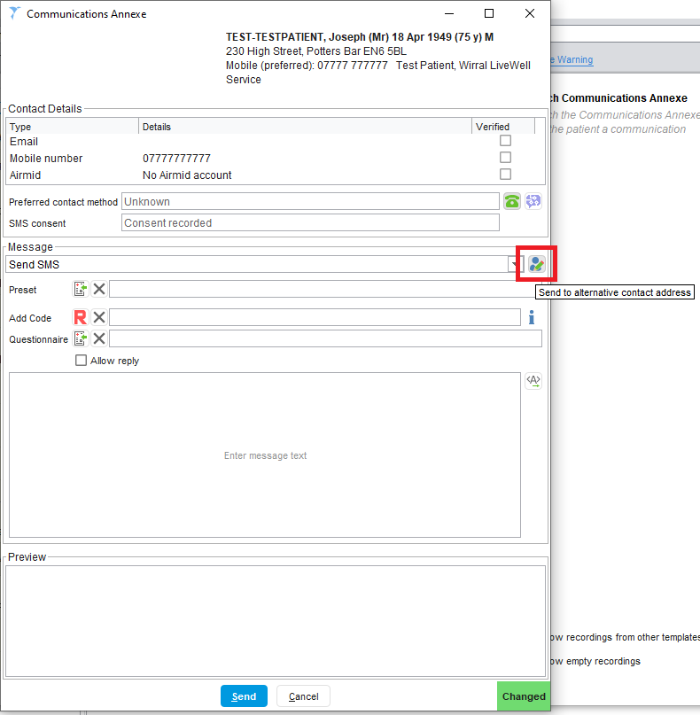

The alternative contact address field will be displayed. Enter a mobile number as required.

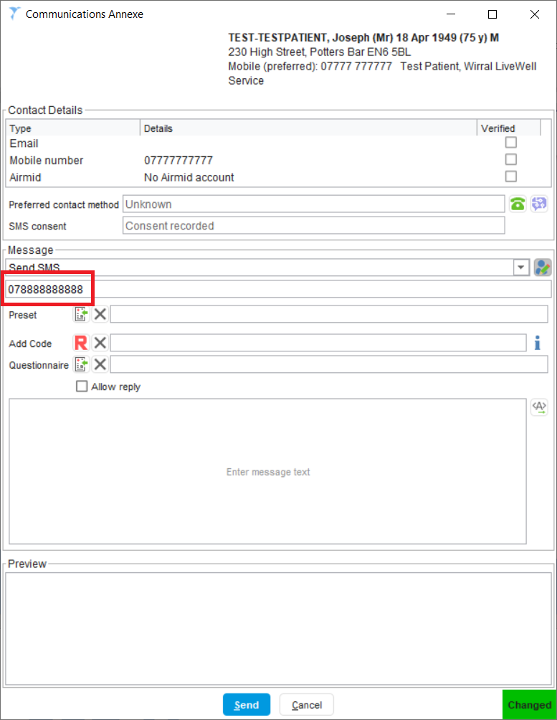

To send the patient a SSNAP Monitoring Chart click on the Select Questionnaire button. Type SSNAP in the Search field and click on Search. The SSNAP Monitoring Questionnaires will be displayed. Select the relevant questionnaire (Weekly or Monthly Monitoring) and click Ok.
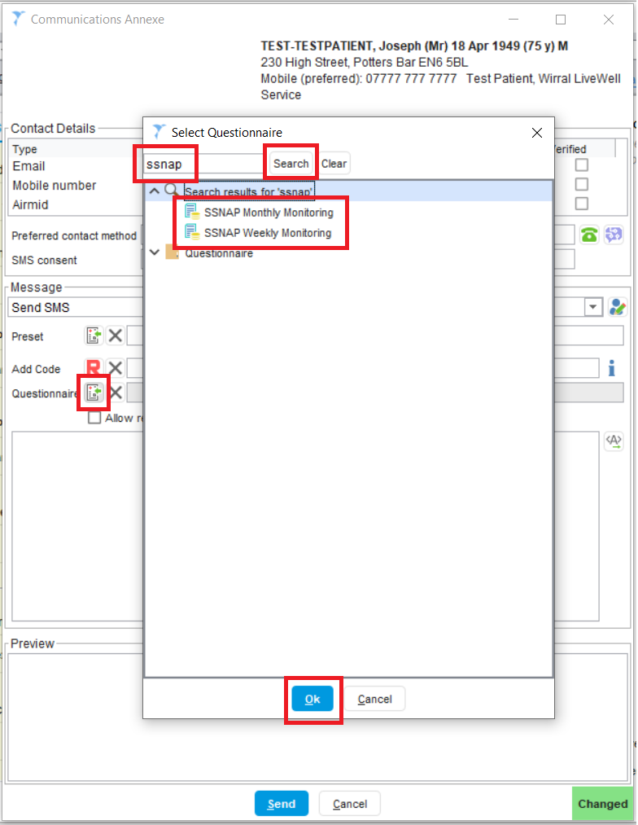

Select the Recipient of the message (this is the person or team within your organisation who will receive the response from the patient – received as a SystmOne Task).

Type in any additional text you would like to send the patient. This will appear in the body of the message that the patient receives.

To send the message select Send. The message will be sent when you save the record.
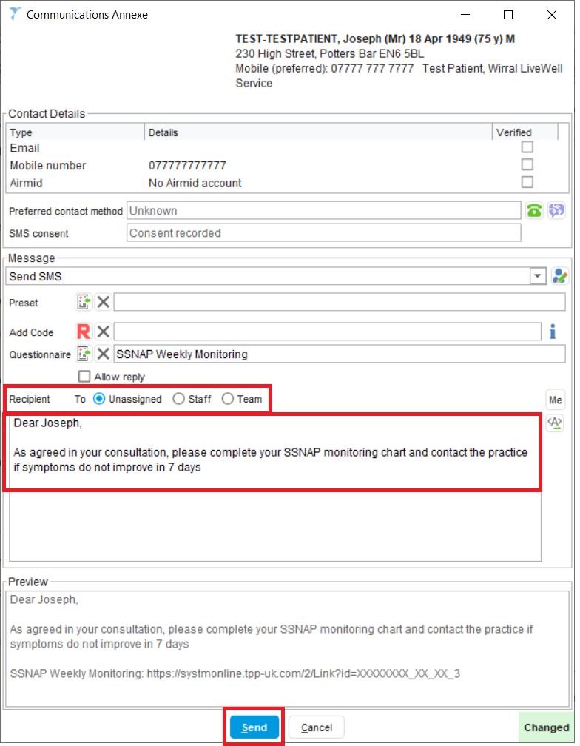

Step 8 – Scheduled Tasks

To follow up with the patient you might want to send a Scheduled Task as a reminder. This can also be useful to remind you or a colleague to send the patient an invitation to complete a consultation satisfaction questionnaire as part of the SSNAP feasibility study around 4 weeks after their original consultation. A Scheduled Task will appear in your organisation’s Task List on the day it has been scheduled to arrive.

To create a new Scheduled Task from the SSNAP Dashboard, select New Scheduled Task.

Please note: you may want to adopt your organisation’s standard safety netting processes by using other SystmOne functionality such as Recalls or adding the patient to a Waiting List.

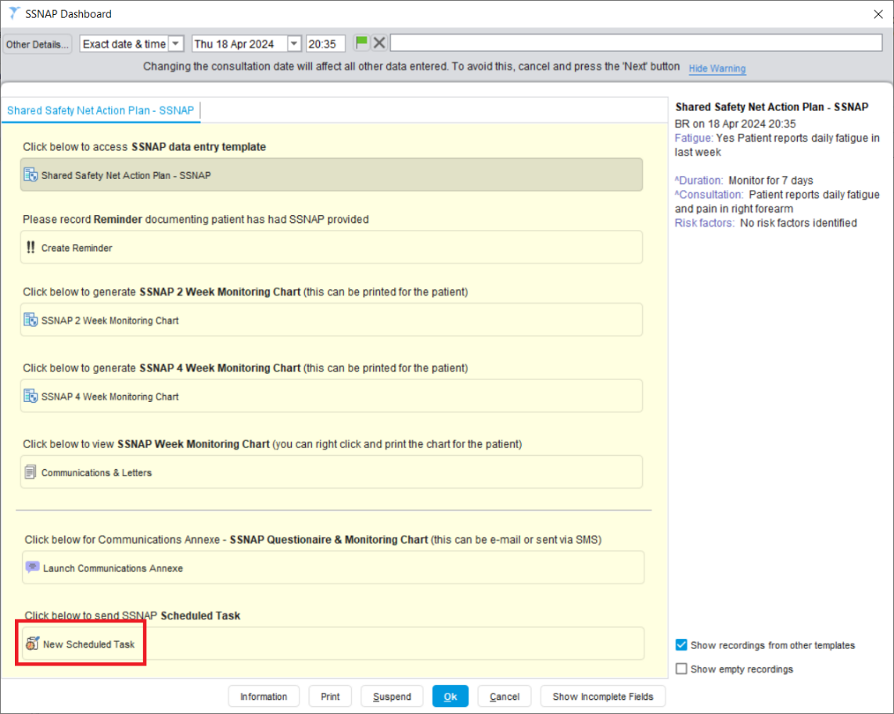

The Scheduled Task box will be displayed. Select a Task Type from the drop-down box.

Select a Task Recipient using the radio buttons (this is the person or team within your organisation who will receive the SystmOne Task).

Type in the required text into the Task Body.
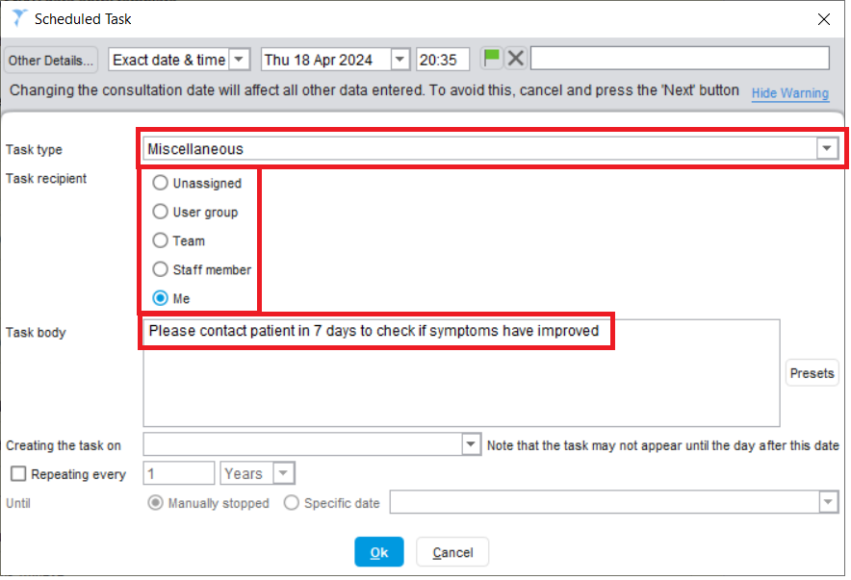

Click on the Creating the task on drop down box. A calendar field will appear. Select the date that you would like to create the task.

Please note: the Scheduled Task may not appear until the day after the selected date.

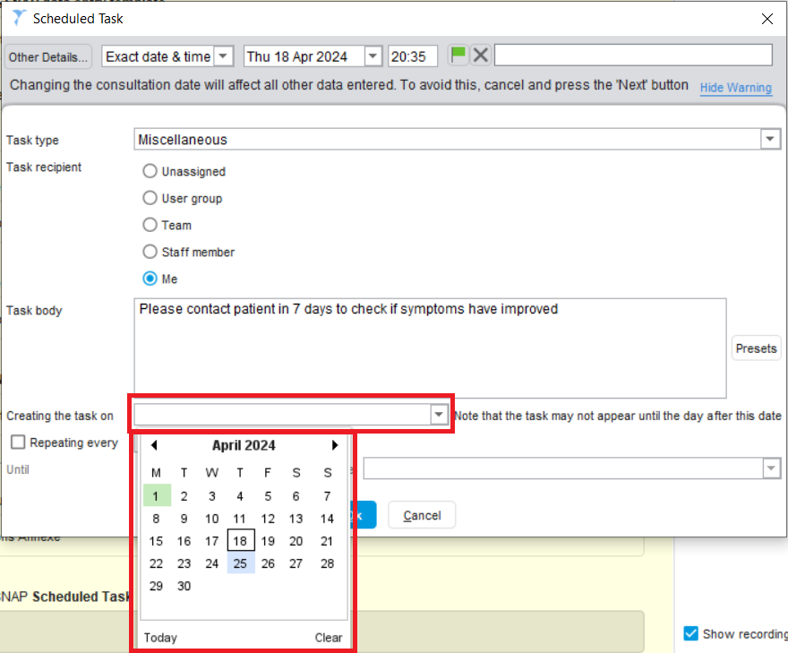

Click OK to create the scheduled task.

To confirm the changes to the SSNAP Dashboard click Ok. Remember to save the record in line with your organisation’s normal processes.

Step 9 – Viewing SSNAP content in the Patient Record

The SSNAP Dashboard and associated content will be viewable from the Tabbed or New Journal tree nodes (see below).

Please note: functionality-specific content such as Reminders and Letters can also be viewed in their corresponding tree nodes. If you do not have these tree nodes available, please contact your SystmOne administrator.

To view the SSNAP Dashboard content only outside of the Journal nodes, select the SSNAP Dashboard from the tree.

The Reminder will be displayed on the Patient Home screen (the default screen displayed whenever a patient record is retrieved). The Reminder will also be displayed in the Reminders node on the tree.

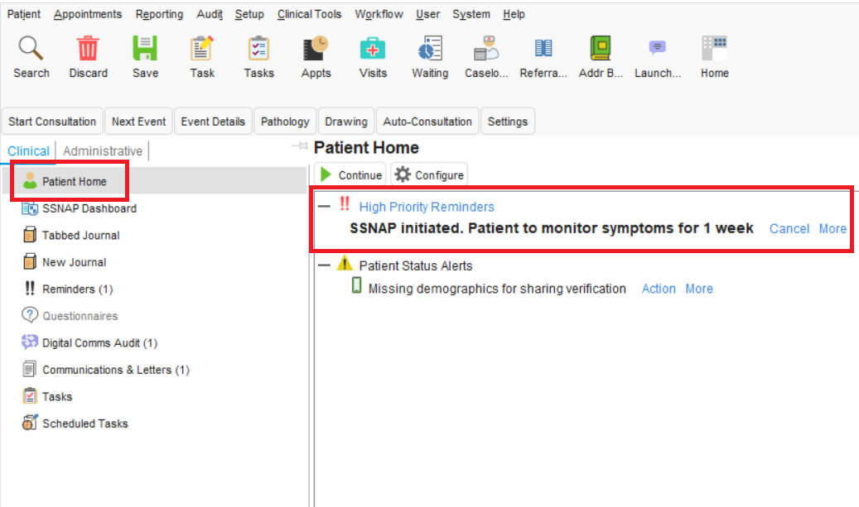
Patient safety-netted with SSNAP

SSNAP Monitoring Charts generated as Integrated Word Letters will be displayed in the Communications and Letters node of the tree.

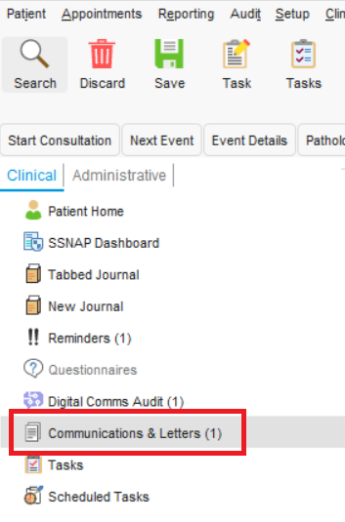

SSNAP letters and Monitoring Charts generated as Questionnaires and sent via the Communications Annexe will be displayed in the Digital Comms Audit node of the tree.

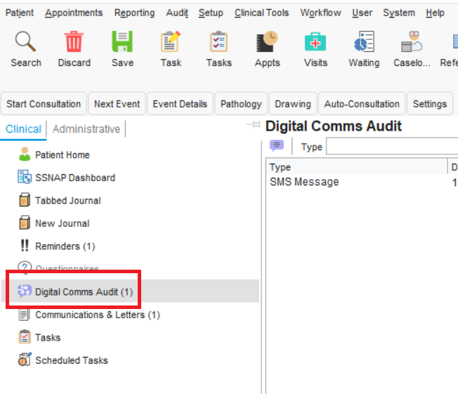

Step 10 – How to Action an Online Questionnaires (Digital SSNAP Monitoring Chart)

Completed digital SSNAP Monitoring Charts are received as SystmOne Tasks via the Task List screen.

To View Tasks at your organisation, Navigate to Workflow (off the main menu) – Task List.

All digital SSNAP Monitoring Charts are received as with a Task Type of ‘Online Questionnaire Completed’. Select the task from the relevant Task folder (you can use the All Tasks – All Open Tasks folder options to see all of your organisation’s Tasks split by Task Type).

Select the Online Questionnaire Completed Task. On the right-hand side of the Task screen, right-click and select Action.

Please note: You may want to set up a Task rule to redirect all ‘Online Questionnaire Completed’ task to a particular person or team. To set this up please contact your SystmOne administrator.

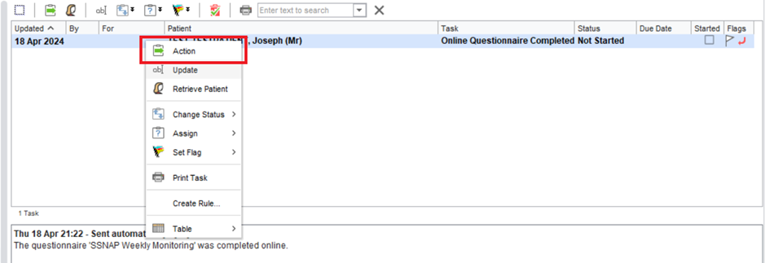

The patient’s completed SSNAP Monitoring Chart questionnaire will be displayed. To save the questionnaire to the patient’s record select File to Record.

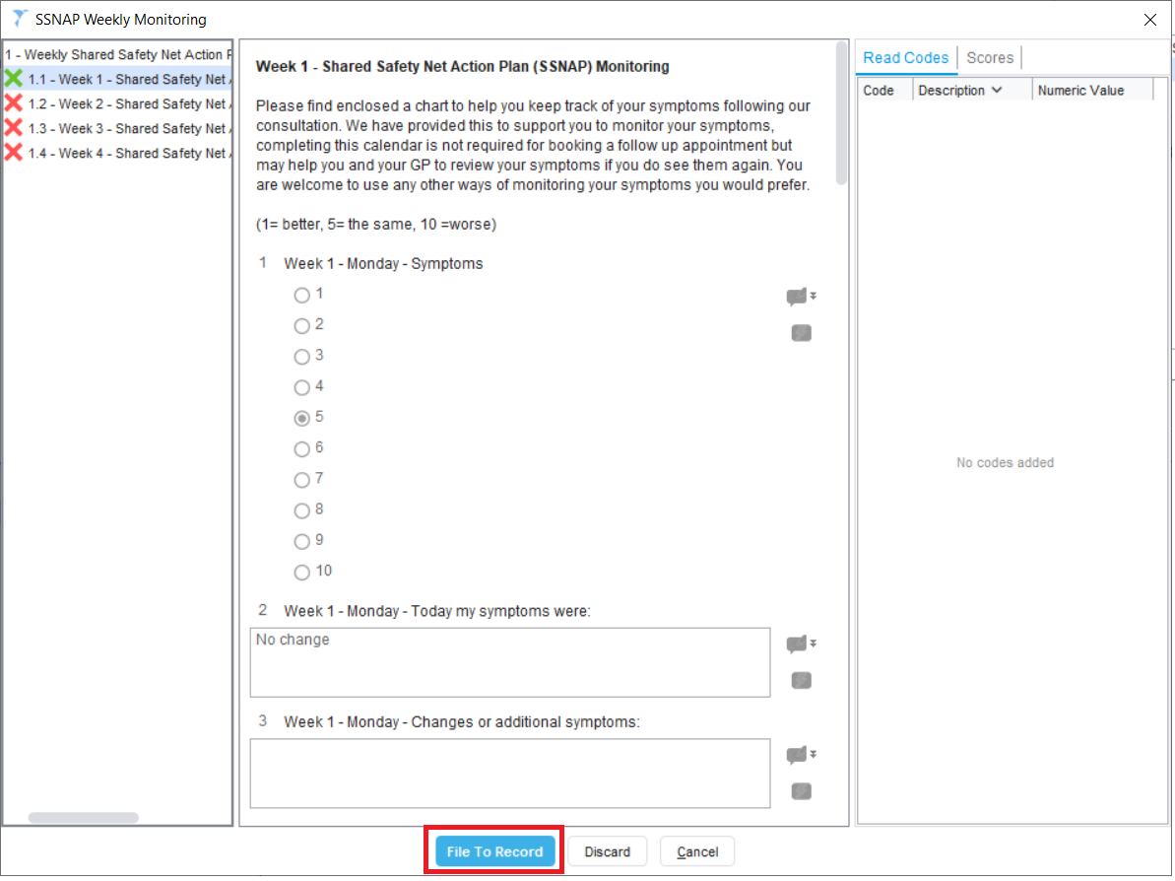

The SSNAP Monitoring Chart questionnaire will be saved in the patient record and can be viewed via the Tabbed Journal, New Journal or Questionnaires node of the tree.
