
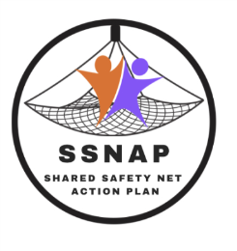

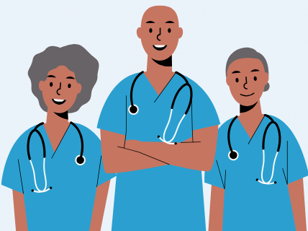
We’re involved in safety-netting research!

The surgery is taking part in a feasibility trial led by Bradford Teaching Hospitals NHS Foundation Trust about safety-netting adult patients with non-specific symptoms which could be an early sign of cancer.
As we’re in the intervention arm of the study, we’ll use a new SystmOne template called the Shared Safety Net Action Plan (SSNAP). SSNAP is designed to engage patients more fully in safety-netting.

Please use SSNAP if you offer safety-netting advice to patients for these symptoms.

We’ll ask patients who received SSNAP to complete a consultation satisfaction questionnaire and if you’re involved with SSNAP you’ll be invited take part in an interview or focus group with the research team to tell them what you think. It’s up to you whether to do so.

For more information including patient eligibility and training, contact:
Hannah Gregson (Research Fellow): hannah.gregson@bthft.nhs.uk

For a tailored staff poster, including the contact details of the PI at your surgery, please contact Hannah at the email address above.


Thank you!

