
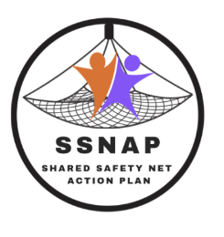
INSERT SURGERY NAME AND LOGO

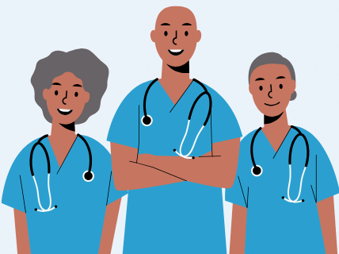
We’re involved in safety-netting research!

The surgery is taking part in a feasibility trial led by Bradford Teaching Hospitals NHS Foundation Trust about safety-netting adult patients with non-specific symptoms which could be an early sign of cancer.

As we’re in the control arm of the study, all this involves is:
- entering a code for eligible patients in SystmOne;
- inviting coded patients to complete a consultation satisfaction questionnaire;
- taking part in an interview or focus group with the research team to tell them what you think about the research. It’s up to you whether to do so.

For more information, including patient eligibility for coding and training materials, contact:

ADD PI NAME
ADD RESEARCH FELLOW DETAILS.



Thank you!

