
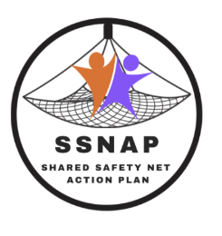
INSERT SURGERY NAME AND LOGO


Our surgery is taking part in research about care of adult patients with symptoms, like tiredness or weight loss, which could have different causes.

If you see a doctor or nurse in the next few months about such symptoms they may advise you to keep an eye on them and come back if they don’t go away or get worse. This is called ‘safety-netting’. We’re using a tool called the Shared Safety Net Action Plan (SSNAP) to encourage patient involvement in safety-netting.

- We may ask you to complete a brief questionnaire about safety-netting. You’ll be invited to talk to the research team from Bradford Teaching Hospitals NHS Foundation Trust about this too. It’s ok if you don’t want to be involved and it won’t affect your care.

- Information from our records about adult patients with such symptoms will be looked at by the research team. This information will be anonymous (we won’t be able to tell who it belongs to) and we’ll only look at information from patients who are signed up for data sharing.

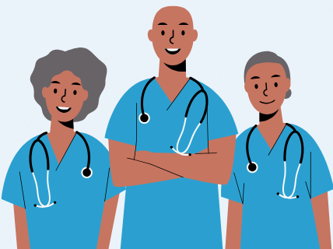
To opt out of data sharing go the National Data Opt-Out webpages of NHS Digital, available through this QR code:
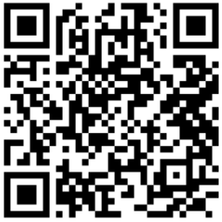

Or call NHS Digital Contact Centre on 0300 303 5678 (Mon-Fri 0900-1700).

If you’ve got any questions, contact [ADD RESEARCH FELLOW DETAILS].

