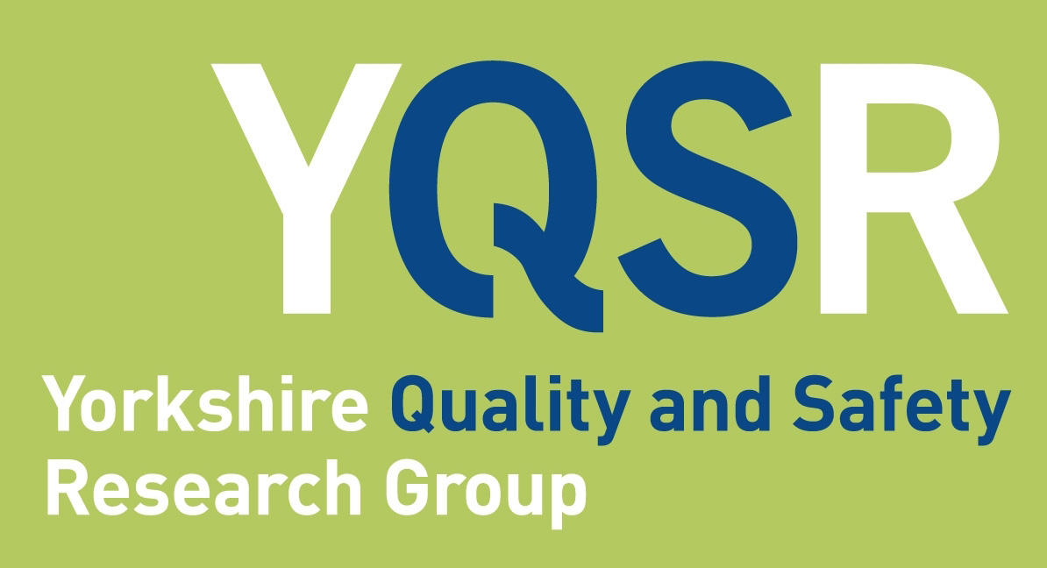

Quality & Safety Seminar

Matt Fogarty
NHS England and NHS Improvement national patient safety team

Evolving patient safety

Abstract
The seminar will discuss some key aspects of our changing understanding of, and approach to, patient safety in the NHS. Discussion points will include our approach to the role of individuals and systems in patient safety incidents, the importance of culture and the need to ensure our approach to learning from incidents is based on a good understanding of error theory. These issues will be presented in the context of the NHS Patient Safety Strategy and how some of the key components of the Strategy link to our evolving understanding of the topic.

Biography
Matt is currently Deputy Director of Patient Safety (Policy and Strategy) for the national NHS Patient Safety team. Prior to this Matt held a number of roles as a Civil Servant, including as a Private Secretary to the Minister of State for Health. Before joining the Civil Service, Matt was a research scientist and gained his PhD in Developmental Neuroscience at University College London in 2006

Thursday 20th May2021
12.30 - 13.30pm
Online via Zoom
Book your place:
https://www.eventbrite.co.uk/e/yqsr-seminar-evolving-patient-safety-tickets-148634097587

For queries please contact Siobhan.mcHugh@bthft.nhs.uk or Helen.Smith@bthft.nhs.uk

