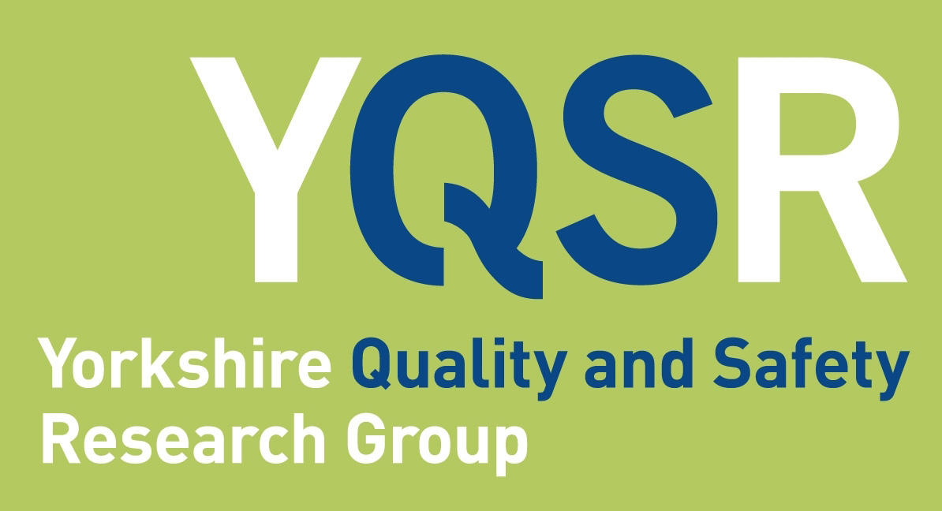

Quality & Safety Seminar

Dr Roman Kislov
Manchester Metropolitan University

Knowledge brokering to get evidence into policy and practice: Escaping the ‘dark side’

Abstract
This talk will reflect on the rise of knowledge brokering as a strategy for translating scientific research into healthcare policy and practice. Drawing on a 10-year programme of research conducted in a large-scale collaborative research partnership, it will explore different dimensions and types of knowledge brokering and discuss implications for evaluating its effectiveness. Particular attention will be paid to the ‘dark side’ of knowledge brokering and strategies that could be used to address it.

Biography
Dr Roman Kislov is a Reader in Organisation Studies and Acting Head of Decent Work and Productivity Research Centre at Manchester Metropolitan University, an Honorary Senior Research Fellow at the Institute for Health Policy and Organisation, University of Manchester, and an Adjunct Associate Professor at the Australian Centre for Health Services Innovation (AusHSI), Queensland University of Technology.
Roman conducts qualitative research on the processes and practices of knowledge mobilisation, with a particular interest in communities of practice, intermediary roles, organisational learning and implementation of change. His work crosses disciplinary boundaries between organisation studies, public administration and health services research. Roman’s work has recently appeared in Public Administration Review, Organization Studies, Public Administration, Implementation Science and BMJ Quality and Safety.
Roman is currently a Deputy Theme Lead for Implementation Science in the National Institute for Health Research Applied Research Collaboration (NIHR ARC) Greater Manchester—a large-scale partnership between universities, NHS providers and third-sector organisations aiming to produce research that responds to the needs of local health and care system across the region.

Thursday 22nd April 2021
12.30 - 1.30pm
Online via Zoom
Book your place:
https://www.eventbrite.co.uk/e/yqsr-seminar-knowledge-brokering-to-get-evidence-into-policy-and-practice-tickets-140970806477

For queries please contact Siobhan.mcHugh@bthft.nhs.uk or Helen.Smith@bthft.nhs.uk

