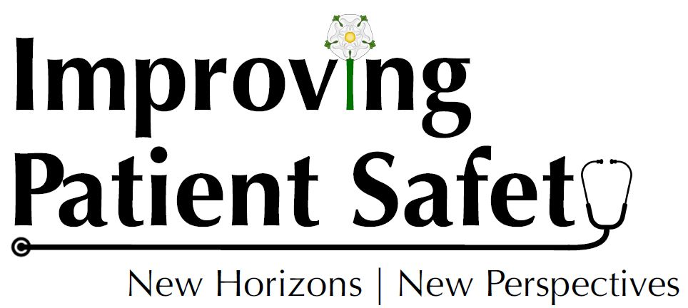

Abstract POSTER proposal form
15th and 16th October 2019, Cloth Hall Court, Leeds

This conference aims to share knowledge and create a new vision for patient safety research and practice. All poster submissions will be peer reviewed by a team of researchers, improvement specialists, patients and clinicians.

Title
No more than 15 words please

Theme
☐ Doing safety differently: moving from Safety I (focusing on when things go
wrong) to Safety II (learning from things going well)
☐ Involving patients for patient safety
☐ Supporting safety at transitions of care
☐ Implementing evidence and making it stick
☐ The potential (and the risks) of new technology, digital and big data for safety
☐ Quality and safety improvement
☐ Staff engagement and well-being for safer care
☐ Other

Poster description
Please no more than 300 words. If accepted, this description will feature in the book of abstracts.

Background (emphasising why your chosen topic is a priority for healthcare)
Aim(s)
Method (participants, design, setting and analysis)
Results
Implications

Presenter
Title & name:

Affiliation & country:

Qualifications:

Student? (Yes/no)

The deadline for submitting abstracts is 13th September 2019. Please email your
completed form to: IMPSAF2019@bthft.nhs.uk with the email subject:
‘Poster Abstract submission: Improving Patient Safety, New Horizons, New
Perspectives’. If you have any questions or would like any support with this process, please don’t hesitate to get in touch with us using the email above.
